Symbolic AI [follow tutorial questions]

* CW written exercises
* Exam in December [all module material] [strictly in exams means have brackets in – all of them]
* Lecture 1
  + What is logic? Consists of **syntax** [formal language], **semantics** [meaning for formal language] and **proof theory** [arguing in formal language]
  + Design systems that reason and infer using logic
  + Propositional logic: propositional atoms and boolean connectives and repeated connectives [care with brackets]
  + 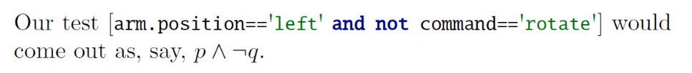
  + In automated reasoning useful to use tree [parsing]
  + Literals and clauses
  + Text

    Description automatically generated
  + Text

    Description automatically generated
  + Graphical user interface, text, application, website

    Description automatically generated
  + Text, table

    Description automatically generated
  + Graphical user interface, text, application

    Description automatically generated
  + Text

    Description automatically generated
  + Text

    Description automatically generated with low confidence
* Text, letter

  Description automatically generated

